WESTERN MICHIGAN UNIVERSITY


STAT 5870: BIG DATA USING PYTHON

SUICIDE AND DEPRESSION TEXT CLASSIFICATION USING MACHINE LEARNING
BY

ALICE INYAN, AUGUSTINE ENNIN, ABODA RADWAN, & AWUDU SANDOOG

Introduction
Suicide is a major global public health crisis. According to the World Health Organization (2025), approximately 720,000 people die by suicide each year, making it the third leading cause of death among individuals aged 15 to 29. In the United States alone, nearly 49,000 suicide deaths were recorded in 2023, roughly one every 11 minutes (CDC, 2025). Early detection of suicidal ideation can be lifesaving, yet traditional clinical screening reaches only a small fraction of at-risk individuals.
Social media platforms have become one of the few places where people openly express suicidal thoughts. Reddit (on subreddits such as r/SuicideWatch) contain thousands of posts explicitly signaling suicidal ideation, offering a unique opportunity to study and detect these signals automatically. The ability to reliably identify suicidal intent from text could enable earlier intervention by moderators, crisis counselors, or automated flagging systems.
This project addresses the research question: Can we automatically and accurately detect suicidal ideation in Reddit posts using machine learning? We compare classical text representation techniques (Bag-of-Words and TF-IDF) with contextual embeddings from a modern transformer model (BERT) across multiple linear classifiers. The goal is to determine which combination of text representation and classifier achieves the best trade-off between performance and interpretability on a large-scale real-world dataset of 232,074 Reddit posts.
Methodology
The methodology employed a publicly available dataset of 232,074 Reddit posts collected via the Pushshift API, where posts from r/SuicideWatch were labeled as suicide (positive class) and posts from r/depression and r/teenagers were labeled as non-suicide (negative class). Text preprocessing involved lowercasing, removal of URLs, mentions, hashtags, and special characters while preserving apostrophes, followed by collapsing multiple spaces. The cleaned data was stratified-split into 70% training, 15% validation, and 15% test sets.
Three text representation techniques were compared. Bag-of-Words and TF-IDF representations were created using unigram and bigram features, with minimum document frequency of 2, maximum document frequency of 0.95, and a vocabulary limited to the top 5,000 features. For the advanced approach, BERT-base-uncased embeddings were extracted using the [CLS] token representation with a maximum sequence length of 128 (training was performed on a 2,000-sample subset due to computational constraints, while validation and test sets used the full data).
Two linear classifiers, Logistic Regression and LinearSVC, were trained on each representation. All models were evaluated on the held-out test set using accuracy, test error, and confusion matrices, with training time also recorded.

Embedding Models
Bag-of-Words (BoW) is the simplest text representation model, creating a vocabulary of every unique word in the corpus and converting each document into a vector based on word counts. While fast and easy to interpret, its primary limitation is its complete disregard for word order and the underlying semantic meaning of the text. This means it cannot differentiate between "I am not happy" and "I am very happy" based on the arrangement of the words.​
TF-IDF stands for Term Frequency-Inverse Document Frequency. It's a statistical measure used to evaluate how important a word is to a document in a collection or corpus of documents.
The core idea is that a word's relevance is determined by two factors:
- How frequently does it appear in a specific document (Term Frequency).
- How rarely does it appear across all the documents in the collection (Inverse Document Frequency).
The final TF-IDF score is the product of these two components
$$TF\left(t,d\right)=\frac{(Number of times term t appears in document d)}{(Total number of terms in document d)}$$
$$IDF\left(t,D\right)=\log{(\frac{Total number of documents in corpus D}{Number of documents containing term t})}$$
$$TF-IDF\left(t,d,D\right)=TF\left(t,d\right)*IDF(t,D)$$
BERT (Bidirectional Encoder Representations from Transformers) is a language model developed by Google and the key aspects of BERT are:
- Text Classification
- Named Entity Recognition (NER)
- Question Answering (Q&A)
- Paraphrase Detection
- Summarization/Generation
BERT, on the other hand, is built upon Transformer encoder stack and is uniquely powerful because it processes text bidirectionally. Unlike other models that read from left-to-right, BERT simultaneously considers the context of all surrounding words. This allows it to generate contextualized word embeddings.

Results & Analysis
EDA Findings
Exploratory data analysis on the cleaned dataset (232,074 posts) revealed a perfectly balanced distribution with 50% suicidal and 50% non-suicidal posts. Suicidal posts were significantly longer, with many exceeding 1,000 characters, while most non-suicidal posts were short (median approximately 200 characters). Word-count distributions confirmed this pattern: suicidal posts had markedly higher median and variance in length.
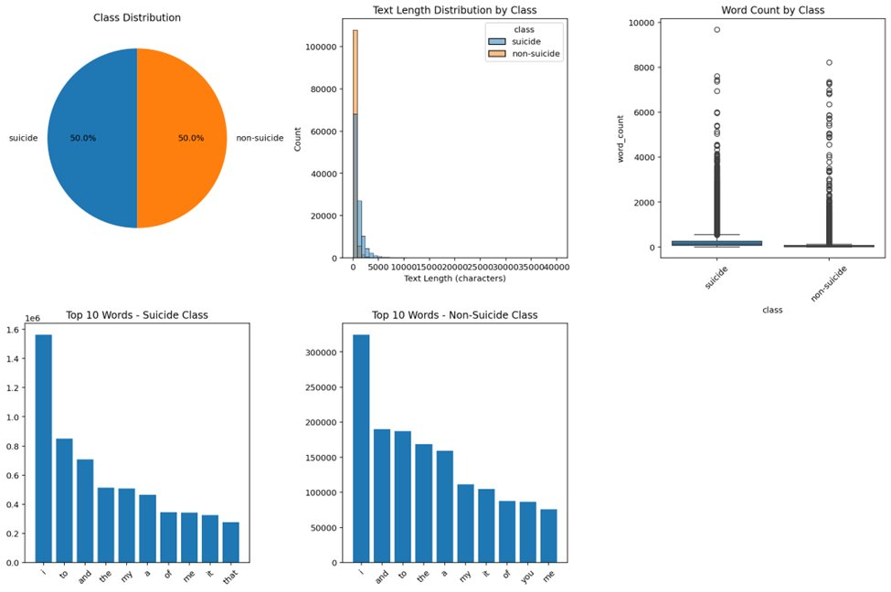

Figure 1: EDA Findings

Predictions
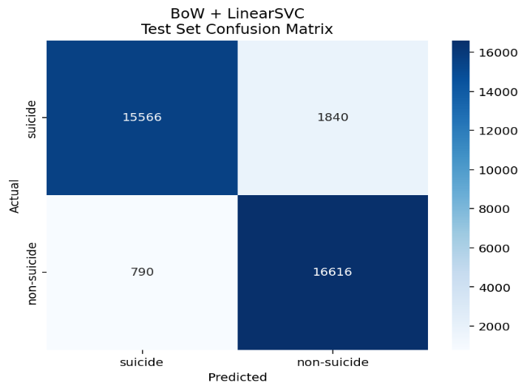
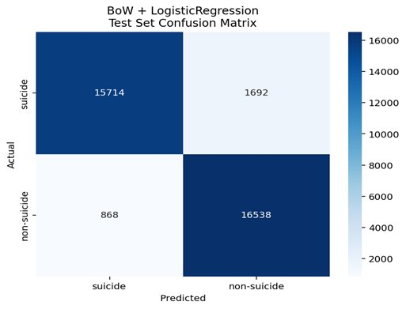
Using the Bag of Words, the results shown below show the actual vs the predicted using Logistic Regression and LinearSVC, with the predicted suicide being 15,714 & 15,566 respectively.
Figure 2: BoW using Logistic Reg
Figure 3: BoW using LinearSVC

The same was done for TF-IDF and the findings were more accurate compared to the BoW as it showed for the Logistic Regression more predicted suicide and in LinearSVC, 16,101 & 16,143.
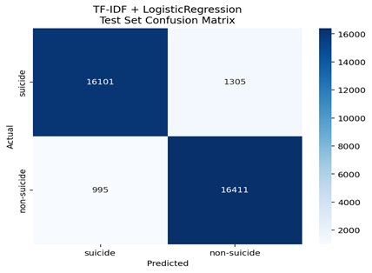
Figure 4: TF-IDF using Logistic Reg
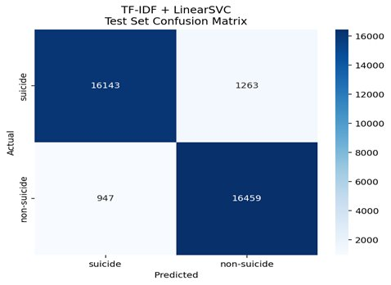
While BERT is considered the more advanced embedding method, it required a more reliable computer and more time to compile all the data to predict the outcome, however after using it for an extended amount of time it showed less reliable results compared to the previous embedding methods, 15,922 & 15,673 for predicted suicide.
Figure 5: TF-IDF using LinearSVC

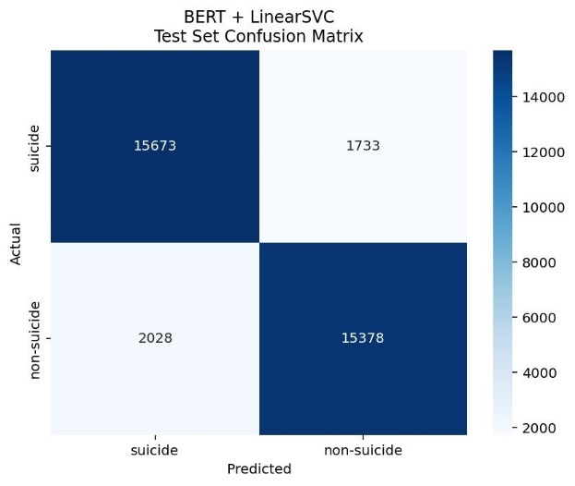
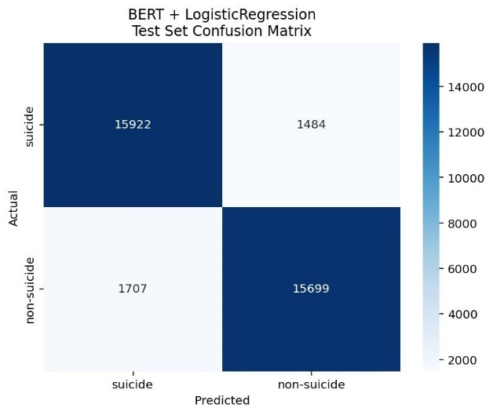
Figure 6: BERT using LinearSVC
Figure 7: BERT using Logistic Reg

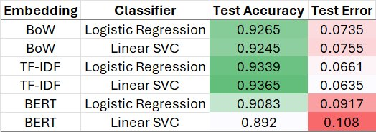
Evaluation Metric
Table 1: Comprehensive Results Comparison

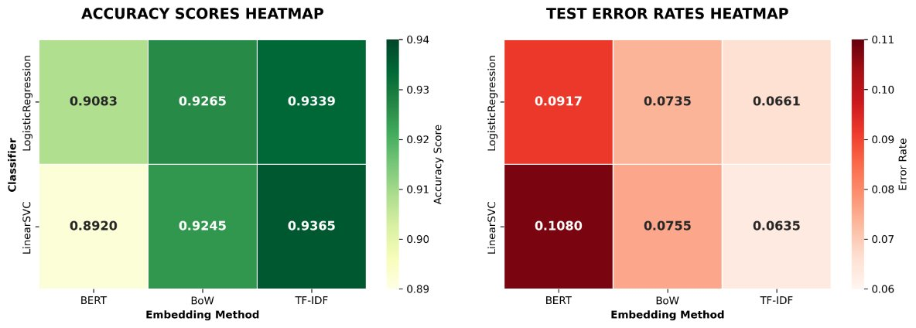
Figure 8: Heatmap
Conclusion
Our analysis determined that the combination of LinearSVC and TF-IDF yielded the best classification performance, achieving the lowest error and an accuracy of 93.7%. To potentially enhance these results further, future research should explore other classification methods, such as Multinomial Naive Bayes, Decision Trees, or Neural Networks. A key future application of this project is to implement a feature that sends a notification to users who post suicidal comments, urging them to seek additional help. Additionally, to improve the model's representativeness and generalization, more diverse datasets should be collected randomly from various platforms, including Facebook, X (formerly Twitter), and Instagram.
Reference
- Dataset: https://www.kaggle.com/datasets/nikhileswarkomati/suicide-watch
- World Health Organization. (2025, March 25). Suicide: Fact sheet. https://www.who.int/news-room/fact-sheets/detail/suicide

